**WAN MOHD HELMI BIN ZAHARI**

**More Than 5Years Personal Driving Experience.**

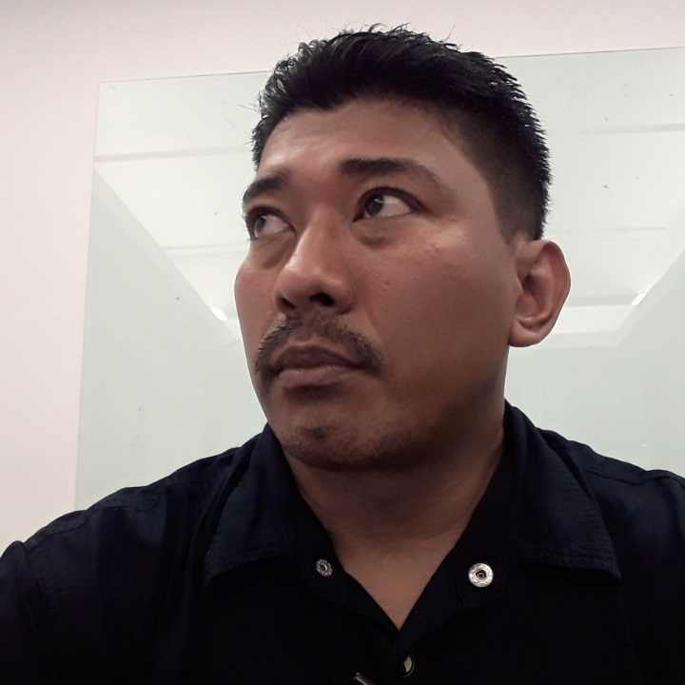

|  |
| --- |
| **Block 8-5-24 Taman Miharja Jln Loke Yew, 55100, Cheras Kuala Lumpur. [**[**wanmohdhelmizahari@gmail.com**](mailto:wanmohdhelmizahari@gmail.com)**]** |
|  |

**Age**: 45 Years

**Date of Birth**: 04 Oct 1979

**Nationality**: Malaysian

**Religion**: Islam

**Race**: Malay

**Gender**: Male

**Identity Card Number**: 791004-10-5031

**Status**: Married

**Expected Salary**: RM3000-RM3500

**EDUCATIONS**

**Level**: 1994-1996 S.P.M.V

**Name of Institution**: Vocational Kajang

**Level**: S.P.M.V Grade 2

**SKILLS**

- Technical/Defensive Driving

- Martial Art/ Self Defence

- VIP Body guarding

- First Aid

- Basic Vehicles Mechanics

**COMPUTER LITERACY:-**

- Microsoft Office

- Microsoft Excel

- Microsoft Access

- Power Point

|  |  |  |
| --- | --- | --- |
| **Language** | **Speak** | **Write** |
| English | Intermediate | Intermediate |
| Bahasa Malaysia | Advance | Advance |
|  |  |  |

**Availability**: Immediately

**Availability** **for Outstation**: 100%

- Good act of secrecy.

- Friendly & reliable.

- Punctual & flexibility.

- Hardworking & fast learner.

- Good character & discipline.

- Sense of responsibility & focus on driving.

- Ability to assistance with luggage & cargo.

-Active, available at all times even short notice.

-Maintained vehicle cleanliness & tidiness on daily basis.

-Expertise in basic auto mechanic & performing minor repairs.

-Maintenance such refuelling, oil changing & other minor task.

-Ability to work individually or in team with minimum supervision.

**WORKING EXPERIENCE**

**Company:** Syarikat Pesaka Antah **From:** August 2017- Mac 2018 **Position:** Personal Driver to Tunku Panglima Besar Negeri From,Tunku Nazaruddin Ibni Almarhum Tuanku Jaakfar.(Mas)

Elexis Issaharof Antah R.e (Argentina)

**Company:** Mr.David Johan Vanut(Belgium) Petronas

**From :** Jun 2018 – 12 Mei 2022

**Position :** Personal Driver cum Bodyguard

**Company:** LJK INTERNATIONAL SDN BHD

**From :** Nov-22 to 30/9/23 (**contract Basis**)

**Position :** Personal Driver cum Bodyguard (Dato Sri)

**Referrence**:

Miss Lenny (Antah group)