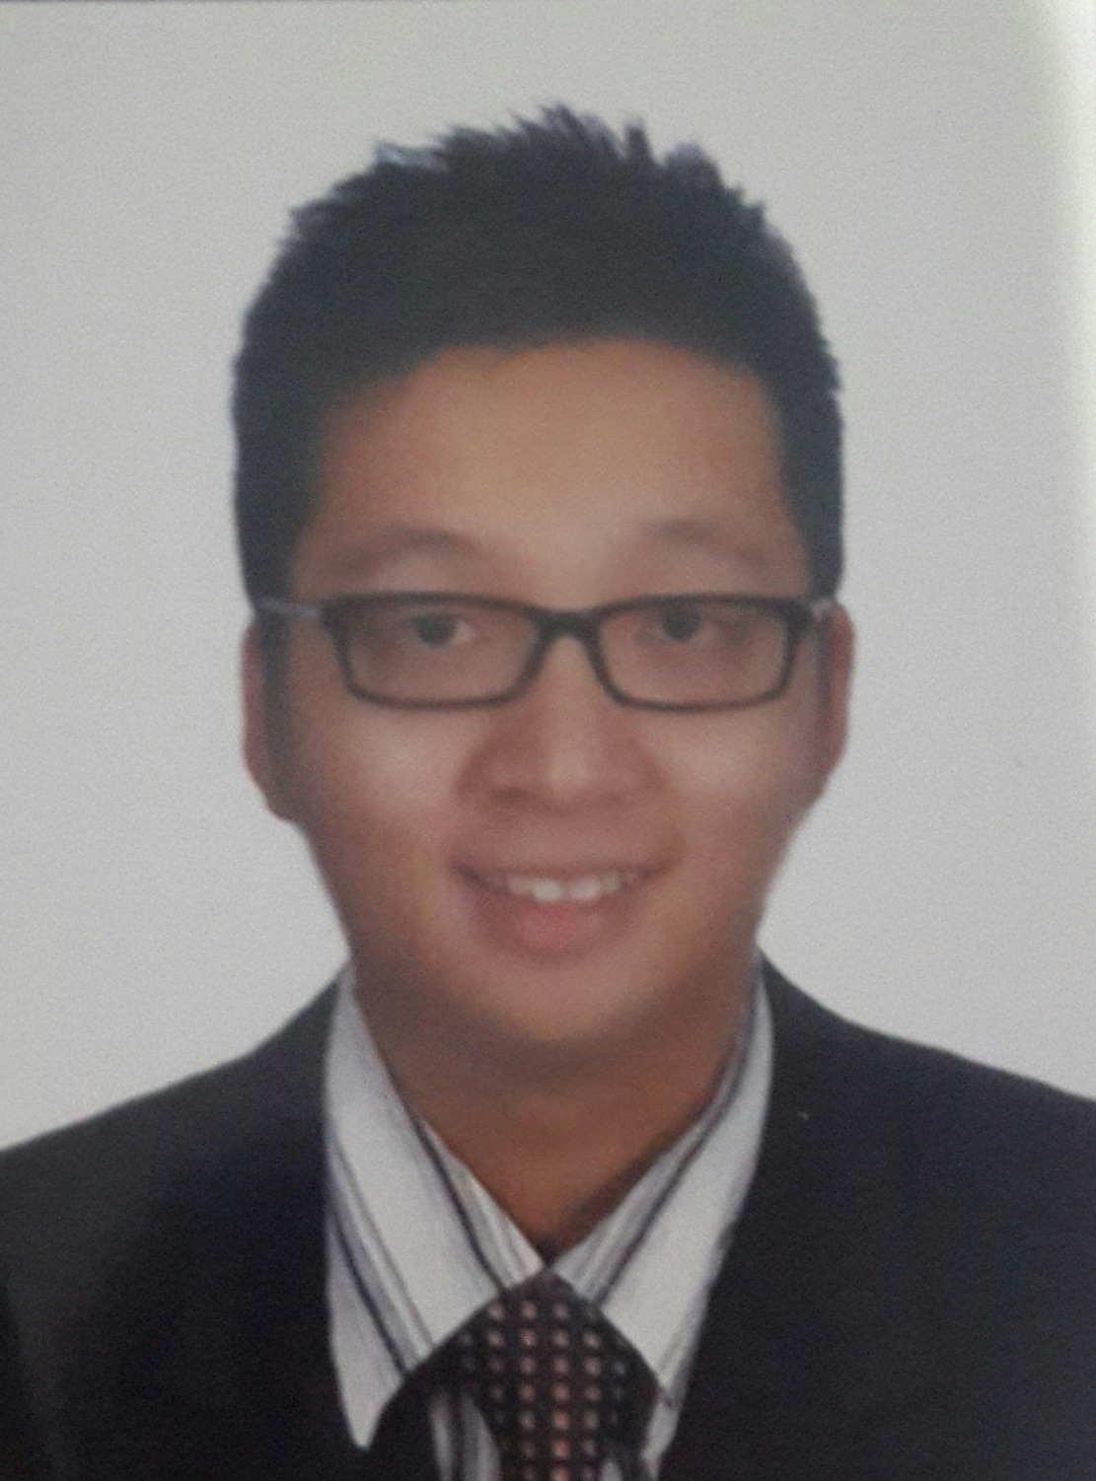
Ngui, Aaron
567 Lorong Stutong 11G Heights Drive Kuching, 93350, Sarawak, Malaysia
Email:aaron.ast@gmail.com ,+60108658888(Mobile)

Resume Summary
Current Position : Head of Department (East Malaysia) in ZTE (M) Corporation Sdn Bhd
Specialization : Engineering - Electronics/Communication
Highest Education : Bachelor's Degree in Engineering (Electrical/Electronic)
Years of Experiences : 18

Employment History

2011 - Current
1. ZTE (M) Corporation Sdn Bhd
Position Title (Level) : Regional Manager (East Malaysia)
Specialization : Engineering - Electronics/Communication
Role : Management
Industry : Telecommunication
Work Description :

1.Rollout of Celcom Digi Mergo project in East Malaysia. Completed 1022 Consolidations in EM, 100 Swap Sites,
350 Decomm sites from 1/6/2023 to 7/11/2023. Rollout of Umobile 1200 sites from 2019 to 2022. Rollout of TM NGN sites. Managing 10 Project Managers, 20 Engineers, 200 installation workers.
Rollout of Digi New sites and upgrade sites in East Malaysia. Total of 2400 sites (between 2014-2017)

2. Successfully swapped 1200 sites for the role out period of 18months starting from 16 May 2011.

3.From June to October 2011 manage 1000 Technical Sites Survey Report.Kick off Installation of ZTE in Sarawak and Sabah. Achievement--- From 08/08/2011 to 15/08/2011, helping ZTE to secure 155 TSSR within 1 week in Sabah. Completed Technical Site survey for Sarawak 489/489 sites and Sabah 415/415 within 5 months time.

4. October 2011-December 2011 completed 168 pre installation sites in Sarawak. and 123 sites in Sabah.

5. 100% successful swap rate of 112Sites in 1.5months. Taking care of End sites-Collection Point-Toc transmission readiness as well. Completed 200 Sites Installation within 3 Months.

6. In 2017, Being the head of region for East Malaysia, monitoring 3 projects ---- Digi, Umobile, Webe.

7. Managing 10 engineers, 6 main contractors with total of 150 workers.

2010 - Apr 2011
2. Nera (M) Sdn Bhd
Position Title (Level) : Implementation Manager (Manager)
Specialization : Engineering - Electronics/Communication
Role : Management
Industry : Telecommunication
Work Description :

1. Manage and monitor on the progress of the project rollout in Kuching from the year 2009 until 2011.

2. Secured 120 Hops or equivalent to 12.3million Ringgit Malaysia project for Nera in Kuching from the kick start of the installation until the Final Acceptance by Digi.

3. Responsible to train groups of project technical team in surveying, installation, testing and commissioning.

2009 - March 2010
3. Nera (M) Sdn Bhd
Position Title (Level) : Implementation Coordinator (Senior Executive)
Specialization : Engineering - Electronics/Communication
Role : Telecommunication Engineer
Industry : Telecommunication

Work Description :

1. To handle the 3G project from Digi Phase 2B rolled out in Kuching. Starting from the Site suvey supervision.

2. Installation of Nera Evolution Expand Link.

3. Testing and Commisioning of Nera Evolution Expand Link.

4. In March 2009, backing up the Klang Valley team from Shah Alam in bringing up the sites in order to hand over to Digi for the product launching of 3G. Together under the team are Nera's Norway staff( Johan), 2 Nera Bulgaria staffs ( Zoran and Rado), Nera's Singapore staff (Steven) and Nera's philipines members.

5. Responsible for Site Pre Acceptance.

6. Responsible in the planning task includes defining the project objective and developing a plan to accomplish the KPI Targets.

7.Orgainsing responsibility in identifying and securing necessary resources, determining tasks that must be completed, assigning the tasks, delegating authority, and motivating team members to work together on the project. Resources include both personnel and financing

2008 - 2009
4. Top Count Sdn Bhd
Position Title (Level) : Project Manager (Senior Executive)
Specialization : Engineering - Electronics/Communication
Role : Telecommunication Engineer
Industry : Telecommunication

Work Description :

1. Dealing with our customer Telekom Malaysia doing cabling for D-side and Fibre optic.
2.Migration of CDMA from existing RILL technology.

June 2006 - Apr 2008
5. DigiField Sdn Bhd
Position Title (Level) : Project Engineer/Project Coordinator (Senior Executive)
Specialization : Engineering - Others
Role : Management
Industry : Telecommunication

Work Description :

1)Project Coordinator. Monitoring the Ericsson's swap project phase 4 for Digi Telecommunication in East Malaysia(Sabah&Sarawak).

2)
(a)Organize installation team on hot swap or cold swap work for equipment Ericsson 2102 to 2106i and
(b)2202 to 2206 under NUP4 123 sites Sabah and Sarawak
(c)Installation, testing, commissioning (1800 and 900) and integration with MSC/BSC.
(d)Performing test call and Edge monitoring after site on air.
(e)Produce acceptance and site documentation on hand over to customer.

Equipments handled:
(f)Transmission – Ericsson Mlink E.
(g)Ericsson – BTS 2102, 2202, 2106i, 2206 and BBU.

3)Optimization and full configuration of RBS 2000 family.

4)Project Management on Ericsson traffic node. Testing and commisioning of Traffic node project in East Malaysia.Total of 85 sites in Sabah and Sarawak. Provide O&M to Ericsson Malaysia under Digi's Project

5)Sites survey for Ericsson.Drawings (Autocad)

6)People management (represents the company to deal with sub contractors and also the principle -Ericsson) and materials arrangement

Oct 2005 - 2006
6. Telekom Malaysia Berhad
Position Title (Level) : graduate Trainee (Fresh / Entry Level)
Specialization : Engineering - Electronics/Communication
Role :
Industry : Telecommunication
Work Description :

1) Assist Engineer in carrying out monthly maintenance of the telecommunication equipment. Getting to know more about the structure of Telekom Malaysia. Studied about the operation of the maintenance site, including the cabling, switching and transmission site.

2) Troubleshoot the streamyx fault.

Dec 2004 - 2005
7. TopCount Sdn. Bhd
Position Title (Level) : Vendor (Fresh / Entry Level)
Specialization : IT/Computer - Hardware
Role : Part Time
Industry : Computer / Information Technology (Hardware)
Work Description :

Installation of Streamyx .

Educational Background

Graduation Date: 2006
Bachelor's Degree of Engineering (Electrical/Electronic)
Major : Electronics
Institute/University : Multimedia University Malaysia, Malaysia
Grade : Grade B/2nd Class Upper

Graduation Date: 2000
Higher Secondary/STPM/"A" Level/Pre-U of
Major : Alpha Engineering
Institute/University : Multimedia University, Malaysia
Grade : Grade A/1st Class

Certification
Nera Evolution Xpand Super PDH (2009)
Certification of Proficiencies for Optical Fibre (2008)
Ericsson Traffic Node Worldwide-Sweden 2007 (2007)
Certification of Proficiencies for CablingProvider (2004)

Personal Particulars & Preferences

Date of Birth : 18 Nov 1982
Nationality : Malaysia
Gender : Male
IC No. : 821118-13-5129
Possess Own Transport : Yes
Availability : Immediately after notice period of 3 month(s)

Additional Info

OBJECTIVE:

Dedicate individual with good background in telecommunication and related to customer service. Fast learner with excellent problem solving skills and has the ability to manage difficult situations under adverse conditions. Reliable, trustworthy and independent with strong communication skills, facilitate a high level of collaboration among co-workers in a team-oriented environment and ability to work closely with end customer. Multi-skilled BSS, BTS and Transmission (PDH) engineer with experience in the installation, commissioning, testing, trouble-shooting as well as operation & maintenance (O&M). Worked and trained with various transmission technologies including PDH & SDH, digital microwave radios, BTS equipment, wireless local loop system and several test equipment / instruments. With12 years of experience in the field of telecommunications, having joined and worked for multinational company locally and abroad.

HIGHLIGHTS OF DELIVERED PROJECTS:
1. Ericssons NUP4
2. Ericssons NUP5
3. Ericssons Traffic Node
4. Nera Evolution Expand
5. Telekom RILL to CDMA Migration
6. Telekom under laying cable and over head cables
7. Telekom Fibre optic underlaying
8. Telekom Fixed line installation
9. ZTE Dnemo swap project In Malaysia
10. ZTE-Digi Project (since 2011-Present)
11. ZTE Umobile Ran share exit
12 ZTE TM NGN project (2021- Present)
13. ZTE Alibaba-Sains Sarawak Project

