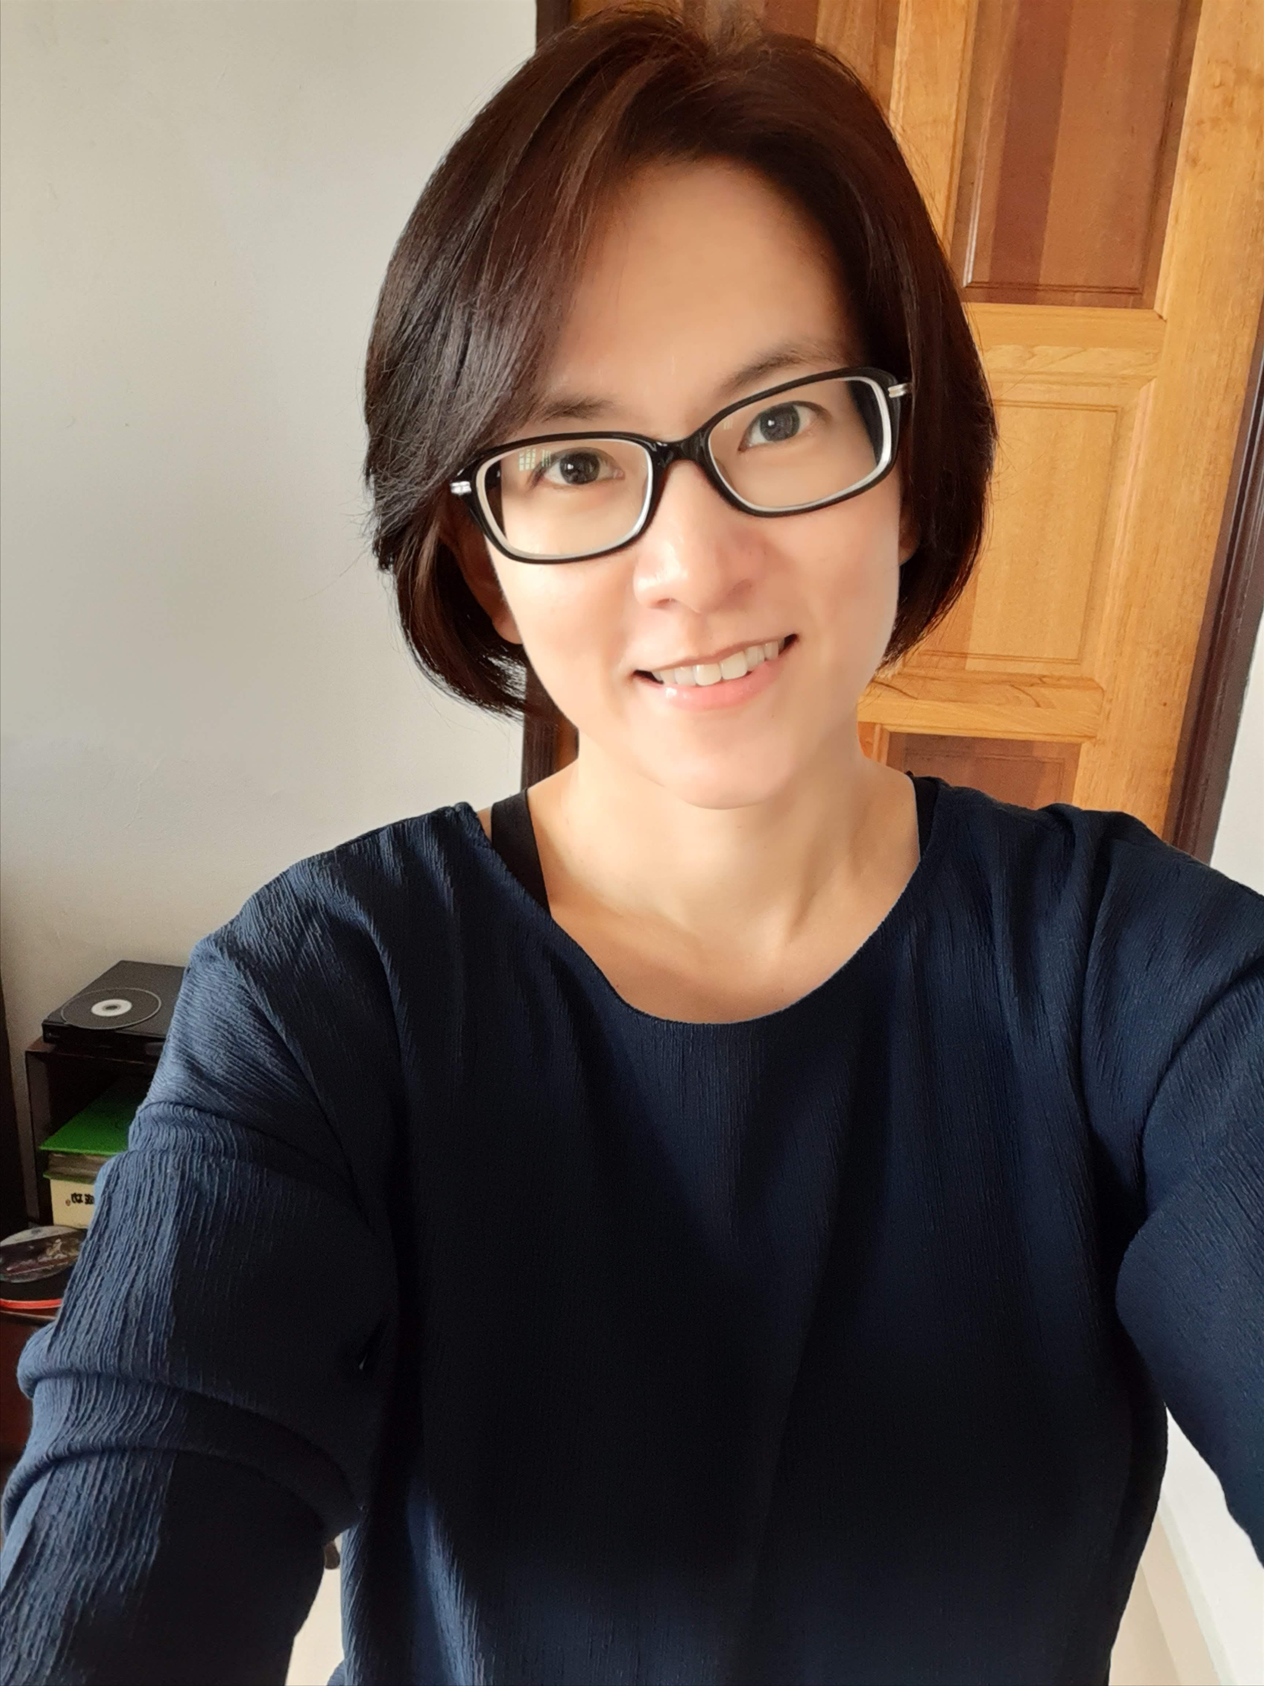 |  | SYLVIA WEE
SUMMARY  Highly capable with good interpersonal and communication skills. Detail-oriented, well-organized, and efficient.  Personable, diplomatic, with the ability to practice sound judgement and discretion.  Able to work both independently and as part of a team.  Contact  MOBILE:  +6-012-201 4668  EMAIL:  syl_wee@yahoo.com  ADDRESS:  39 Jalan 1/3, 46000 Petaling Jaya  Selangor Darul Ehsan  MARITAL STATUS  Married, with children  LANGUAGE SKILLS  English ••••  Bahasa Malaysia ••••  Hokkien ••  COMPUTER SKILLS  MS Outlook •••  MS Word ••••  MS Excel ••••  MS Power Point ••  REFERENCES WILL BE PROVIDED UPON REQUEST |  | EDUCATION  Eu Institute, Petaling Jaya, Malaysia  May 2010 – Dec 2010  LCCI Bookkeeping & Accounting (Level 2 Intermediate)  Stamford Ladies College, Petaling Jaya, Malaysia  Dec 1989 – May 1995  - Diploma in Administrative Management, UK  - Diploma in Executive Secretaryship  - Diploma in Private Secretaryship  SM (P) Taman Petaling, Petaling Jaya, Malaysia  Jan 1985 – Nov 1989  Sijil Pelajaran Malaysia – Grade One  WORK EXPERIENCE  CMY Capital Group – Secretary, Chairman’s Office  Jan 2012 - Present  - Assist in the smooth running of the day-to-day operations of the Chairman’s Office.  - Duties include calls screening, welcoming guests, handling mails, drafting correspondences, preparing reports, maintaining the pantry, purchasing office stationery, managing drivers and maintenance of company vehicles.  - Wrote an office maintenance manual  Auric Chun Yip Sdn Bhd – Secretary to Country Manager, Malaysia  Aug – Dec 2011  - Provided secretarial support to the Country Manager, Malaysia  Integrated Professional Services Sdn Bhd – Admin & Accounts Exec  May 2010 – July 2011  - Provided administrative and accounting support to the Managing Director.  - Took up a certificate in accounting course on a part time basis to better understand work  Boyden CW Global Search Sdn Bhd – Office Administrator  May 2002 – Sep 2009  - Assisted in setting up a formal office  - All duties and responsibilities remained similar to job at Boyden/Garner International.  Boyden International / Garner International – Office Administrator  Oct 1995 – Mar 2002  - Provided secretarial and administrative support to the Managing Director  - Prepared job descriptions and candidate profiles for presentation to clients  - Liaised with clients and candidates on interview schedules, and with hotels on use of meeting rooms / business centre.  - Prepared full set of monthly accounts by leveraging on the knowledge and experience of colleague  - Was in charge of payroll, invoicing and collection of overdue accounts  Harpers Trading (M) Sdn Bhd – Confidential Secretary to GM, East Malaysia  Jun 1993 – Aug 1995  - Drafted correspondences, prepared sales reports, scheduled appointments and made flight arrangements.  Nutri Care Sdn Bhd – Private Secretary to Managing Director  Sep 1991 – Jun 1993  - Prepared correspondence and sales reports  - Recorded minutes of meetings  - Liaised with DCA on registration of company’s products  - Was in charge of office stationery and stock at pantry

